Lab 6: Association Rule Mining with Apriori and FP-Growth
Name: Sudhansu Sekhar Dash
UC ID: 005033968

This lab focused on understanding how association rule mining can be used to discover meaningful relationships between items in transactional data. Using the Online Retail dataset, the lab demonstrated how two popular algorithms Apriori and FP-Growth identify frequent itemsets and generate rules that explain which items are commonly purchased together. The overall goal was to translate raw transaction records into actionable insights that could support retail decision-making such as product placement, bundling, and targeted marketing.
Data preparation and Exploration: The Online Retail dataset was first loaded and examined to understand its structure and content. Missing values were removed, negative quantities were filtered out, and item descriptions were standardized to ensure the data accurately represented real purchases. Basic visualizations such as bar charts were used to display the most frequently purchased products, giving an initial sense of customer buying behavior. A co-occurrence heatmap further illustrated item relationships by showing how often products appeared together in transactions.
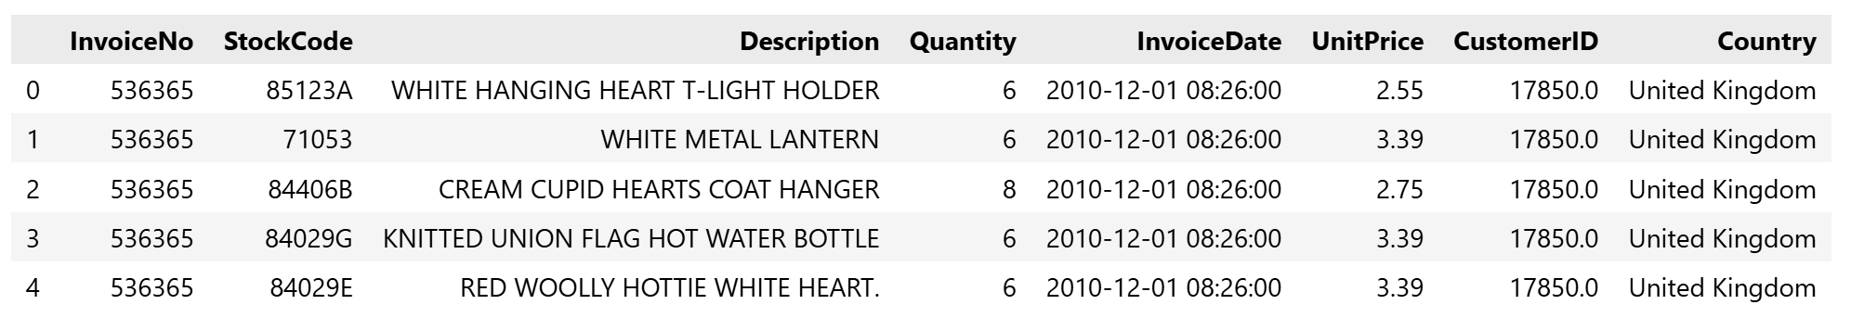
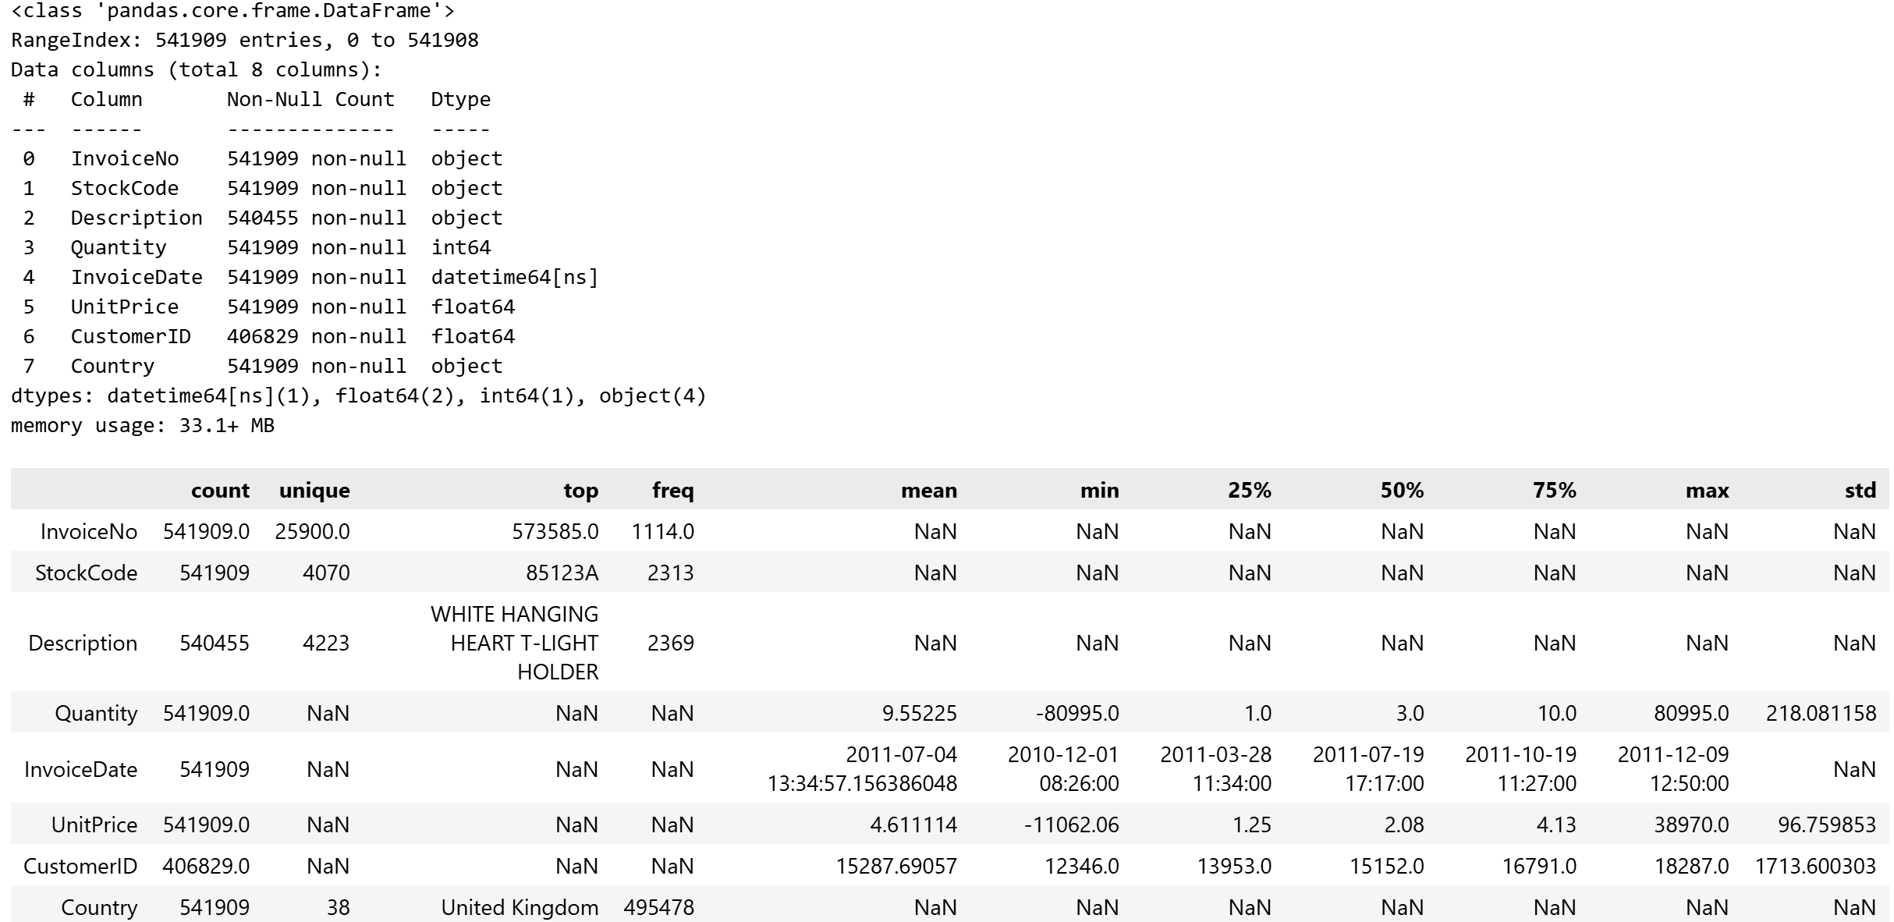
Next, the dataset was transformed into a basket matrix format where each row represented a transaction, and each column represented a product. Binary values indicated whether an item was present in a transaction, enabling the application of frequent itemset mining techniques.
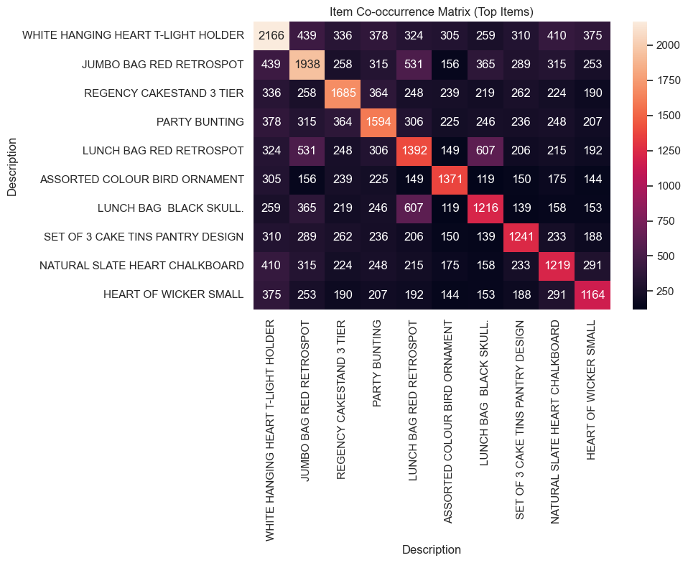
The Apriori algorithm was applied to identify frequent itemsets based on minimum support thresholds. These itemsets and their support values were visualized using Seaborn bar charts to highlight the most common product combinations. The FP-Growth algorithm was then implemented using the same support threshold for fair comparison. FP-Growth demonstrated better efficiency due to its tree-based structure that reduced repeated scans of the dataset.
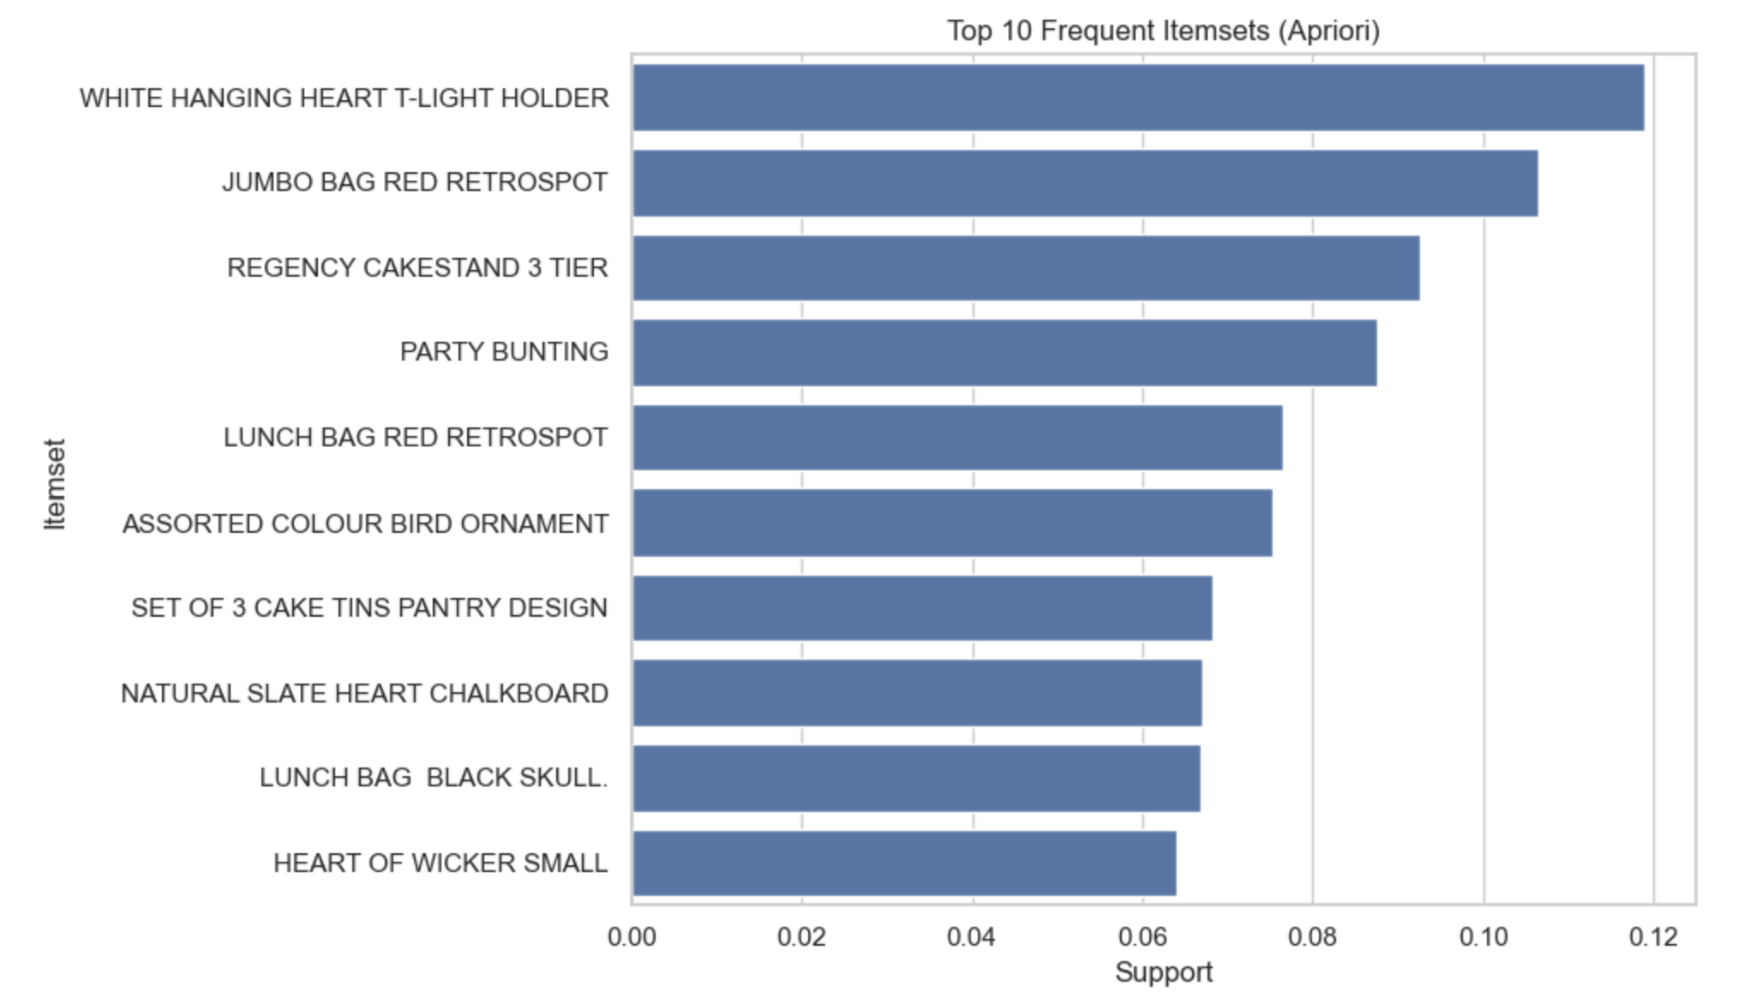

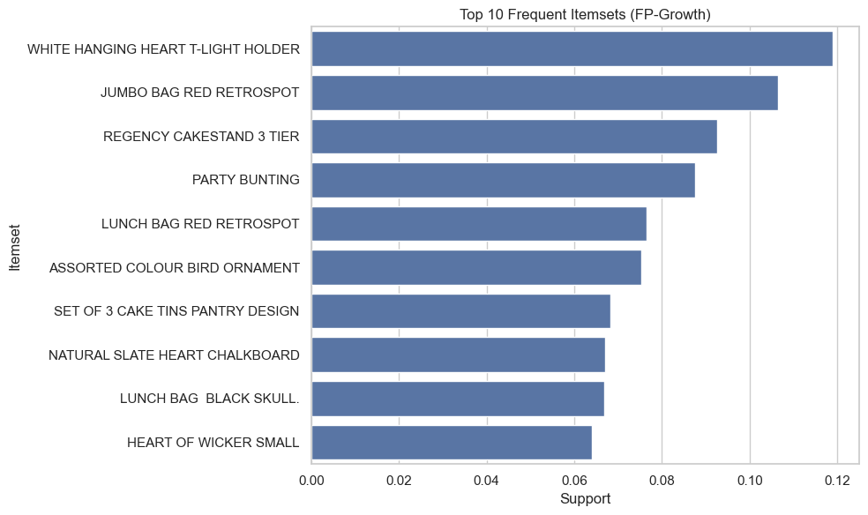
Association rules were generated from the frequent itemsets using confidence thresholds, and metrics such as support, confidence, and lift were analyzed to interpret the strength and reliability of item relationships. Scatter plots of confidence versus lift helped visually identify strong rules.

Key Insights Gained
Strong purchasing patterns highlighted frequent product pairings that supported cross-selling and promotional strategies. FP-Growth consistently outperformed Apriori in terms of speed while producing similar results. Visualizations made complex patterns easier to understand and supported strategic decision-making applications such as targeted marketing and recommendation systems.

Challenges Encountered
The main challenges included file path errors, dataset formatting issues, parameter tuning for optimal support and confidence levels, and performance constraints with Apriori. These were resolved through careful data cleaning, threshold adjustments, and algorithm selection optimization.

Conclusion
This Lab provided valuable hands-on experience with association rule mining techniques, reinforcing the importance of data preparation, algorithm efficiency, and visualization in transforming raw transaction data into actionable business insights.

Github:

